YISHUN JUNIOR COLLEGE
2009 JC2 PRELIMINARY EXAMINATIONS
H1 CHEMISTRY SUGGESTED ANSWERS

Paper1

1 | 2 | 3 | 4 | 5 | 6 | 7 | 8 | 9 | 10
C | B | B | A | C | D | C | C | B | C
11 | 12 | 13 | 14 | 15 | 16 | 17 | 18 | 19 | 20
A | D | D | C | B | C | A | A | B | C
21 | 22 | 23 | 24 | 25 | 26 | 27 | 28 | 29 | 30
D | A | A | B | D | C | C | A | A | D

Paper 2
Section A

1 | (a) | (i) | Electrons
 |  | (ii) | Electrostatic forces of attractions between the electrons and protons
 |  | (iii) | Protons and neutrons
 | (b) | (i)
  species | protons | neutrons | electrons
  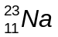 | 11 | 12 | 11
  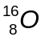 | 8 | 8 | 8
  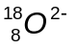 | 8 | 10 | 10
 |  | (ii) | Na₂O + 2HNO₃ → 2NaNO₃ + H₂O
 |  | (iii) | Let x % = abundance of oxygen-16  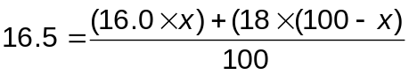  = 75%  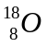 = 25%
 | (c) | (i) | Nitrogen: 1s² 2s² 2p³ (electrons have to be unpaired)  Oxygen: 1s² 2s² 2p⁴
 |  | (ii) | 1st I.E. of N = 1400 kJ mol⁻¹  1st I.E. of O = 1310 kJ mol⁻¹  The 1st I.E. of O is lower than that of N.  For O, electron is removed from a 2p orbital that is occupied by another electron. Thus, electron experiences inter-electronic repulsion and less energy is required to remove it.
 |  | (iii) | N³⁻
 |  | (iv) | A lot of energy is required to remove all 5 electrons in nitrogen and 6 electrons in oxygen to form a stable octet.
2 | (a) | (i) | 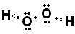
 |  | (ii) | bent, 104.5º
 | (b) |  | 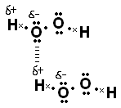
 | (c) |  | Hydrogen peroxide is simultaneously oxidized and reduced in this reaction. Oxidation state of oxygen atom in hydrogen peroxide increase from -1 to 0 to oxygen and decrease from -1 to -2 in water.
 | (d) | (i) | 5.50 x 10⁻⁴ mol
 |  | (ii) | 1 mol of vanadium donates 2 mol of electrons to hydrogen peroxide.  Original oxidation state of vanadium is +3

3 | (a) | (i)
   | Na | Mg | Al | P
  formula | NaCl | MgCl₂ | AlCl₃ | PCl₃  PCl₅
  pH | 7 | 6.5 | 2 | 1
 |  | (ii) | PCl₃ + 3H₂O → H₃PO₃ + 3HCl  or  PCl₅ + 4H₂O → H₃PO₄ + 5HCl
 | (b) | The lattice energy of MgO is more exothermic than NaCl.  Mg²⁺ and O²⁻ have higher charge than Na⁺ and Cl⁻. Hence the attraction between Mg²⁺ and O²⁻ is stronger than Na⁺ and Cl⁻.
 | (c) | (i) | AlF₃ is an ionic compound and a lot of energy is required to overcome the strong electrostatic forces of attractions between the Al³⁺ and F⁻ ions.  AlCl₃ is a simple covalent molecule and less energy is required to overcome the weak van der Waals forces of attraction between the AlCl₃ molecules.
 |  | (ii) | 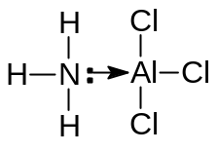
4 | (a) | Empirical formula = C₅H₁₀O  M_{r} = 86 = 5 × 12.0 + 10 × 1.0 + 1 × 16.0  Molecular formula = C₅H₁₀O
   | C | H | O
  % | 69.8 | 11.6 | 18.6
  No. of moles | 5.81 | 11.6 | 1.16
   | 5 | 10 | 1
 | (b) | (i) | A contains a C=C double bond
 |  | (ii) | A contains a –OH group / is an alcohol
 |  | (iii) | A has the 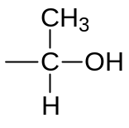 structure
 | (c) | (i) | Orange precipitate
 |  | (ii) | Secondary alcohol (do not accept alcohol)
 | (d) | - Presence of restricted rotation about the C – C bond due to the presence of π bond;  - No two similar groups is bonded to the C with the double bond
 | (e)
  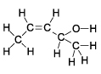 | 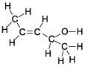
  cis | trans

Section B
5 | (a) | 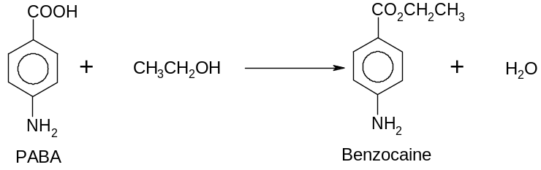
 | (b) | (i) | order of reaction w.r.t PABA is 1  order of reaction w.r.t ethanol is 1  order of reaction w.r.t sulfuric acid is 0  Rate equation: Rate= k[PABA][Ethanol]
 |  | (ii) | k = 0.0200 mol⁻¹dm³s⁻¹  Award if both value and unit are correct.
 | (c) |  | Boltzmann curve – 2 marks, every mistake,-1  Number of particles  Energy  T₁  T₂  E_{a}  T₂>T₁  From the graph, increase in temperature increases the average energy of the reacting particles. Hence the proportion of particles with energy equal to orgreater than the activation energy increases significantly. Therefore the frequency of collisions between reacting particles increases. This increases the number of effective collisions and consequently the rate of reaction.

 | (d) | (i) | heat evolved = mc∆T = 1 x 200 x 4.2 x 13.4 = 11256 J or 11.3 kJ
 |  | (ii) | No of mole of water = 0.025 mol  Enthalpy change of reaction = -11256/0.025 = -450 kJ mol⁻¹
 | (e) | (i) | HX + H₂O H₃O⁺ + X⁻  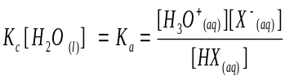  [H₃O]⁺ = √ka.[HX] = √1.5 x 10⁻⁵ x 0.1 = 1.22 x 10⁻³ mol dm⁻³  pH = -log₁₀ [H₃O]⁺ = -log₁₀1.22 x 10⁻³ = 2.9
 |  | (ii) | A buffer solution is one that is able to maintain a fairly constant pH, even when relatively small amounts of acid or alkali are added to it.  When small amount of H⁺ is added, it is removed by  H⁺ + X⁻ → HX  When small amount of OH⁻ is added, it is removed by  OH⁻ + HX → H₃O + X⁻
6 | (a) | (i) | Heat evolved when one mole of liquid ethanol is burnt completely / in excess oxygen under standard conditions
 |  | (ii) | ∆H = – 1411 – (– 1367)  = – 44 kJ mol⁻¹
 |  | (iii) | Under standard conditions, water and ethanol exist as liquids.

 | (b) | (i) | rate  time  R_{f} (Forward rate)  R_{b} (Reverse rate)  t_{eqm}
 |  | (ii) | 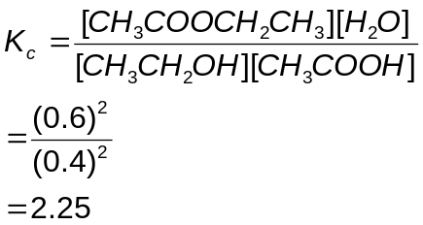
   | ROH | + | RCOOH | Ý | Ester | + | H₂O
  n_{i} | 1 |  | 1 |  | 0 |  | 0
  n_{c} | - 0.6 |  | - 0.6 |  | + 0.6 |  | + 0.6
  n_{e} | 0.4 |  | 0.4 |  | 0.6 |  | 0.6
 |  | (iii) | The equilibrium will shift to the right as concentrated H₂SO₄ is a dehydrating agent thus increasing the yield of the ester.  It also acts as a catalyst and thus increasing the rate of the reaction.
 | (c) | (i) | PCl₅ / PCl₃ / SOCl₂ at room temperature or HCl, heat
 |  | (ii) | Warm the two compounds with NaOH (aq), followed by HNO₃ (aq) and then AgNO₃ (aq)  Chloroethane: White precipitate  Iodoethane: Yellow precipitate
 | (d) | (i) | C: CH₃CHO  D: CH₃CH(OH)CN
 |  | (ii) | Reaction I: K₂Cr₂O₇ (aq), H₂SO₄ (aq), distil  Reaction II: HCN, trace amount of NaOH / NaCN, 10 – 20 ºC  Reaction III: any mineral acid, heat
7. | (a) | 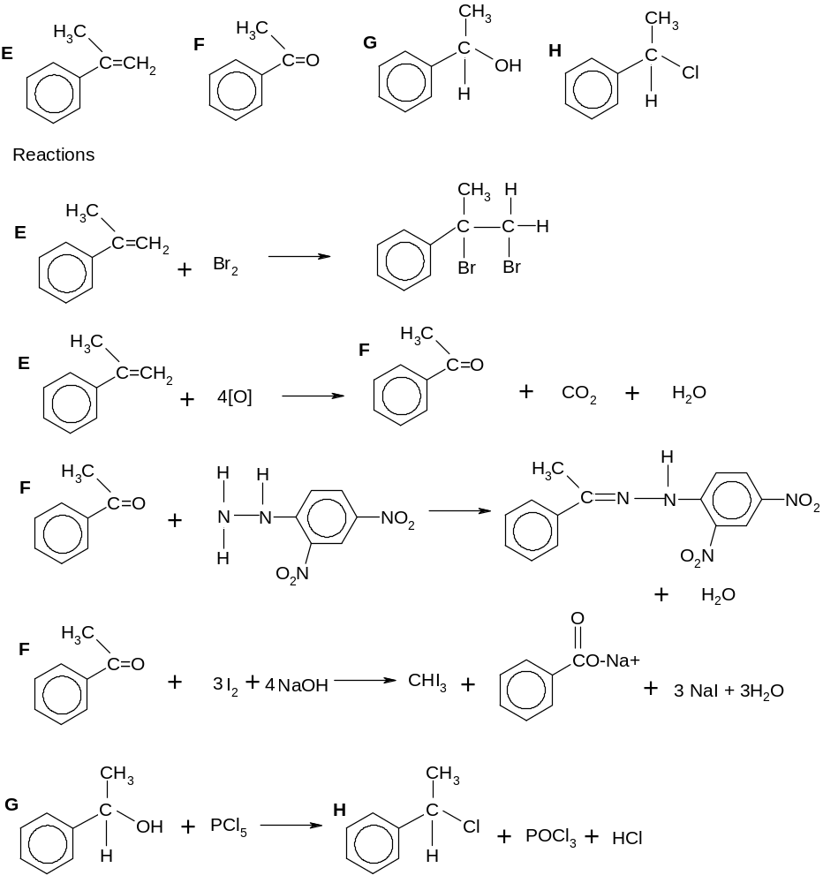
 | (b) | (i) | Acids are proton donor, bases are proton acceptor
 |  | (ii) | [H⁺] = 2 x 0.1  pH = - log [0.2] = 0.70
 |  | (iii) | No of mole of water = 0.025 mol  heat evolved = 0.025 x 126 = 3.15 kJ  ∆T = 3.15/75 x 4.2 = 10  The final temperature of the solution is 35ºC.
 |  | (iv) | Energy  Reaction coordinates  NaOH + H₂SO₄  Na₂SO₄ + H₂O  E_{a}  -126 kJ  (v)
 |  | (v) | another line showing lower Ea, same energy level of products obtained.
 | (c) | CH₂ClCOOH, CHCl₂COOH, Cl₃COOH  CCl₃COOH is the strongest acid as it contains the most number of electron withdrawing chlorine atoms. This is because the charge on the COO⁻ group of CCl₃COO⁻, is dispersed more extensively than in CHCl₂COO⁻and CH₂ClCOO⁻

